**International University of Business Agriculture and Technology**

**Lab Report 09**

Name       : Abdullah Md Jahid Hassan.

Student ID: 20203020

Course     : CSC 440

Section     : A

Semister : Fall 2022

Mobile no : +8801756254873

E-mail       : hassan20203020@gmail.com



**Submitted to**

Rashedul Islam

Date: 08-08-2022

**01**

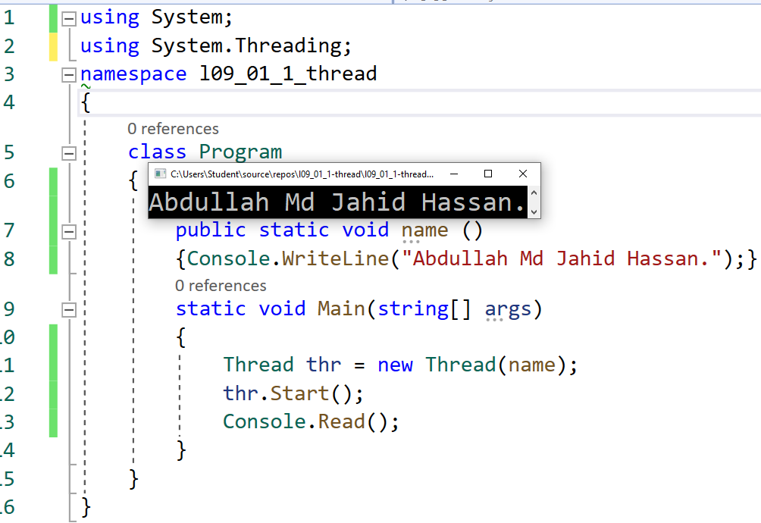

**02**

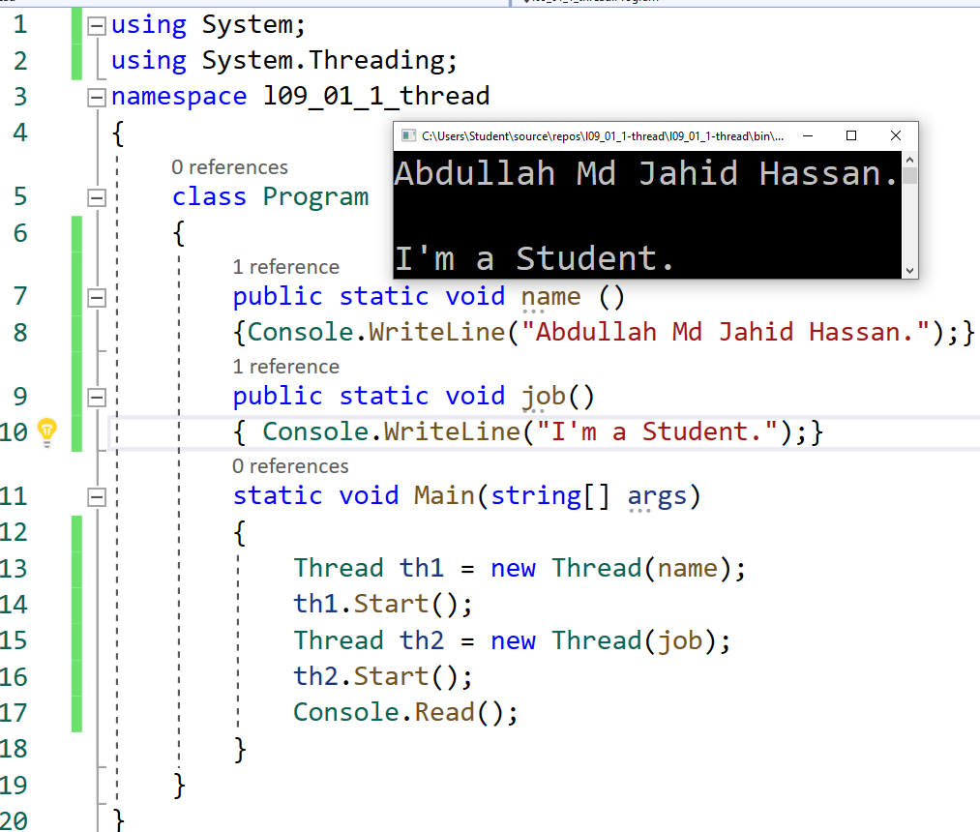

**03**

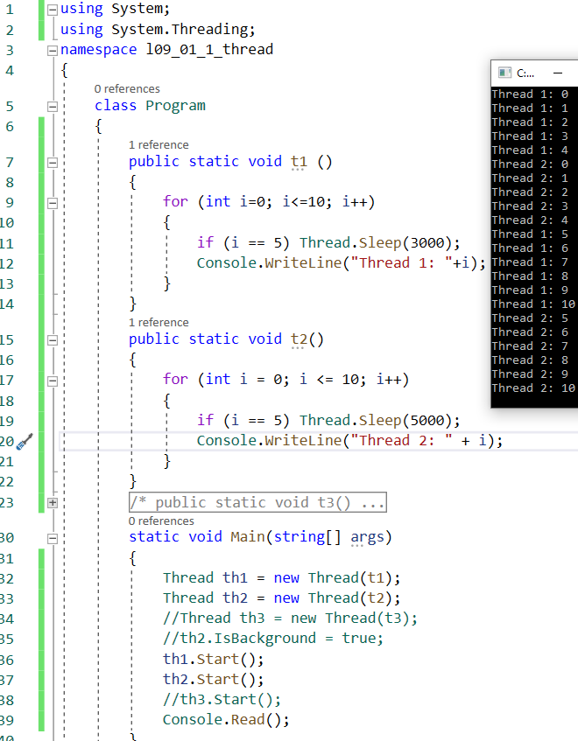

**04**

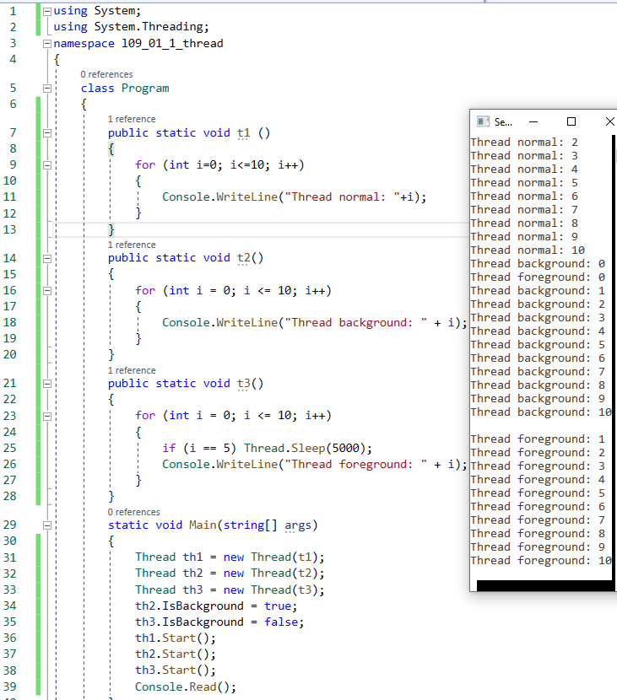

**05**

